Table of Contents

1 Literature Review 2

1.1 Understanding the RAN for Autonomous Driving 2

1.2 What is V2X? 3

**1.2.2** Standards and Protocols 4

**1.2.3** What details and decisions are needed from the c-V2X 5

**1.2.4** Link Level Performance 6

**1.2.5** NR-V2X 7

1.3 Mobile network requirements for fully automated driving 9

**1.3.1** Different options are specified to support redundant transmission at different layers: 9

**1.3.2** Dynamic Division of Packet Delay Budget 9

**1.3.3** Enhancements of session continuity 9

1.4 NR V2X side links 10

**1.4.1** Side link Bandwidth 10

**1.4.2** Synchronization Reference 10

**1.4.3** Triggering of S-SSB (Sidelink Synchronization Signal Block) Transmissions 12

**1.4.4** PC5 QoS Profiles for V2X sidelink 13

1.5 5G NR V2N 14

2 Related Work 16

2.1 Use Larger bandwidths (RBs) with lower coding rate (MCS): 16

2.2 Range as a function of the throughput for C-V2X and 802.11p. 17

2.3 Performance synthesis of C-V2X and ITS-G5: range evolution as a function of the network load. 18

2.4 V2X communication systems consider latency to be an important performance metric as some applications (such as pre-crash sensing) 18

3 Current Application 20

3.1 Data points produced at the current state for sensory data 20

3.2 Sensor data volume of the current state 21

4 Analysis/ Use Cases 22

**4.1.1** V2N latency 22

**4.1.2** V2X latency 23

4.2 DL and UL Throughput 25

**4.2.1** Data rates with the sensor data, signalling and cybersecurity certificate 26

**4.2.2** V2I Traffic Expectancy 26

**4.2.3** V2VTraffic Expectancy 27

4.3 V2N Traffic Expectations 29

**4.3.1** For Signaling, and the basic ACK transmission 33

**4.3.2** To download the needed data from the mobile network 34

**4.3.3** For the live data upstream 35

The radio communication requirements based on the vehicle speed 39

# Introduction

* Data sets
  + The log files generated by the test car
  + 5G testing an open dataset for static and dynamic users for download and a live streaming scenario.
  + Ookla 5G download test results
  + Pending- DT in Oulu region

**Derived from the data**

* The V2X Network traffic demand (network utilization) prediction(V2N,V2V,V2I.I2I..)
* Validate the analysis results based on the Autonomous driving protocols and standards.
* Cross-validate it again with the current 5G network if the 5G network can accommodate the Radio Access Network requirements.
* Suggestions to the current 5G network infrastructure:
  + RSU as a repeater or even a micro or Pico gNB units
  + In building solutions for tunnels and underground parks
  + Merged and directed mobile coverage for expressways
  + The current infrastructure is not ideal for dynamic users

**Important and Novelty facts**

* RSRP thresholds
* Define RSRP thresholds for V2N- inner circle threshold -116 dBm (where V2V communication happens
* Define the same threshold with different speeds up to 250kmph-Using ML regression
* Introduce another threshold for the edge server capabilities (-99 dBm- in Progress)

**Suggest two new thresholds for the V2V**

* Identify two new thresholds for V2V
* Introduce how the pedestrian data needed to be shared

# Data produced by the test Car

For this, we will consider a test drive, displayed below.

Limitations:

* Not a fully autonomous
* No sidelink traffic (V2I/V2P/V2V/V2X)
* To predict the data traffic (DL/UL), we will be considering similar applications and some assumptions.

|  |  |
| --- | --- |
|  | Approximate Distance: 5 km  Start Time: May 23, 2024, 08:20:00.209536  End Time: May 23, 2024, 08:43:36.127128  Time duration: 23 minutes and 36 seconds (1415.92 seconds)  Average speed: 12.71 km/h  Total data points:1.22 million  Total Data volume: 145 Mb |

## Data points produced at the current state for sensory data

## Sensor data volume of the current state

* For different packet sizes, the data rate is as follows, this will be only the sensory data traffic. In the advanced Driving applications, we expect that the packet size will mainly depend on whether the complete cybersecurity certificate is included in the message with a header from 90 Bytes to 350 Bytes when the certificate is included. Fig. 1 shows that the CAM message size ranges from 200 to 700 Bytes.

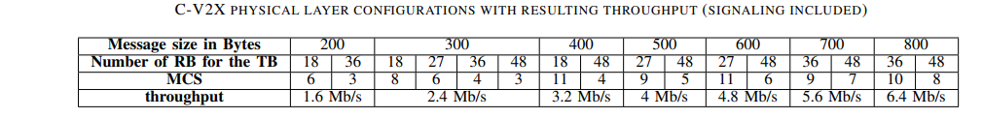

But for Advanced driving, with the sensor data, there will be a signalling and cybersecurity certificate, which will increase the data throughput requirement here. This will be equivalent to the base or signalling only. network traffic for autonomous driving. (The minimum baseline to start with is to function purely based on the onboard sensor while communicating and reacting to V2I and V2V signalling traffic.)

Need to predict the data set based on assumptions, like there will be likely to be live video streaming at least 2, uploading photos, Sensory traffic, and other periodic information received.

# Analysis/ Use Cases

### V2N latency

The global requirement for V2X network latency for Advanced Driving is 30 ms. But based on the global throughput speed data, the current network’s latency in 5G network is 44ms based on the 84000 locations. (Ookla 2023 report).

However, this is commercial Network latency and in V2X communication we will be using dedicated side links with a fixed latency of 10ms. Still, the V2N latency will not be sufficient in the instance we use remote processing or cloud servers to process information.

[Global 5G download speeds up 17% YoY in 2023: Ookla (fonearena.com)](https://www.fonearena.com/blog/416913/global-5g-download-speeds-global-2023-ookla.html)

**Suggestion:** The V2N network must be prioritized, and specific QoS parameters should be implemented, or VPN may improve the V2N latency. And for our advantage in vehicles, we will be using significantly more power full antennas than the cars so the latency will be much improved.

### V2X latency

**In V2X there is a fixed Reselection Window,**

* The time to access resources is fixed. RTT is 20ms and latency is 10ms.
* Not influenced by network load.
* However, if there is a higher number of users the behaviour is as follows,

Figure: ITS-G5 and C-V2X latency as the function of the range for a density of 100 users/km2.

Reference: [(PDF) A Comparison of the V2X Communication Systems: ITS-G5 and C-V2X (2019) | Valerian Mannoni | 96 Citations (typeset.io)](https://typeset.io/papers/a-comparison-of-the-v2x-communication-systems-its-g5-and-c-2dwcvt3plv)

The overall latency is defined here as the average time to receive one packet correctly for a density of 100 users/km2 for 300 Byte packets.

The high value of the Packet Error Rate induced by larger ranges has a significant impact on the number of packets to be transmitted before one is correctly received.

* This will ensure that within the higher traffic areas the latency is fixed, and it is a good safety precaution.

**Suggestion:** The current base station plan is based on mobile traffic distribution. Higher priorities are given to higher user-density areas. Such as Universities, shopping malls and so on.

* We need to focus on vehicle traffic scenarios, such as car parks. These areas should have dedicated base stations, which can cover up to 400m in each sector.
* Most of the car parks will be situated underground and it will require implementation in Building Solutions (IBS) to provide better network coverage focused on V2X sidelines.
* The tunnels and underground routes also needed to have IBS specially focused for V2X sidelines.
* Need to focus on Higher levels of autonomous applications such as parallel parking, lane changing or sensor sharing in cooperative collision avoidance (Urban areas) to have more based stations for the V2X traffic.

## Network Demand

The traffic rates in the V2N network will be based on each application and scenario. These are the 3GPP TR 21.915 version 15.0.0 Release 15, standard rates requirements for Advanced Driving.

Below are the data rates of our test car, with limited sensors only. (No video streams or downloads)

This traffic will be broadcasted via the V2X network, and for Advanced driving, with the sensor data, there will be a signalling and cybersecurity certificate, which will increase the data throughput.

Hence, in the following, we considered a packet size of 300 Bytes as the average size obtained from field tests from a different research DOI:10.1109/VTCSPRING.2019.8746562 (https://typeset.io/papers/a-comparison-of-the-v2x-communication-systems-its-g5-and-c-2dwcvt3plv) but results are also shown for variable packet sizes as in the above.



Below are the data rates for Advanced driving, with the sensor data, signalling and cybersecurity certificate, this will be equivalent to a base or signalling-only network traffic for autonomous driving. (The minimum baseline is to function purely based on the onboard sensor while communicating and reacting to V2I and V2V signalling traffic.)

This will be the V2I and V2V data traffic generated in autonomous driving by a single car.

### Data rates with the sensor data, signalling and cybersecurity certificate

### For Signaling, and the Basic Transmission

We will go with our application where, similarly 150 vehicles are in an urban area (50 per sector) the data traffic will be something like below for the packet size of 300bytes.

Can 5G accommodate this kind of traffic? yes

### V2I Traffic Expectancy

These data rates are from a single car and in an option where there will be 30 cars aligned at a traffic light, the V2I traffic will be approximately 30 times this.

|  |  |
| --- | --- |
|  |  |

If there are 5 traffic lights for a single base station in each scenario, the Sideline traffic for the V2I only will be around, 120 Mbps only for the V2I traffic, and this is within the standard sidelink data rates of 50Mbps.

This is comparatively high traffic to process by the IOT devices with a stand-alone processing power. So I2N connections must have a direct line by optical fibers

### V2VTraffic Expectancy

**V2V**: A car will at least communicate in between 4 to 6 vehicles stacked in a traffic light or a car parking space, and we will run the same data rates for the given.

**Use Case 1:** Level 3 and Level 7 synchronizations when travelling at a Doppler speed of 500kmph.

* First, we need to define the data volume that needs to be transferred. This data may include the,
  + Hazard, traffic and weather details- Roughly around 2 Mb(Based on the sample datas)
  + Transferring Driving safety support and smooth driving- 600 bytes in 10 times a second speed
  + Synchronization ACK- 600 bytes
* Total data to be transmitted = 2.1Mb

**Convert Speed to Meters per Second:**

* Speed of the cars = 250 km/h
* Convert km/h to m/s: = 69.44 m/s (approximately)

**Calculate Time for Communication:**

* Distance between cars to communication to happen 50*2 meters
* Relative speed = Sum of speeds = 69.4469m/s + 69.4469m/s = 138.88138 m/s
* Time for communication (t) = Distance / Relative speed t≈0.72 seconds

**Calculate Data Speed (Mbps):**

* Data to be sent = 2.1 Mb (Megabits)
* Data speed = Data size / Time Data speed≈2.915 Mbps (The average speed if we assume the data has been transferred at a linear speed.

But in an actual context, it will happen as follows, this is if the data speed happens at a distance from 50m, at a transfer_rate_hz = 10 # Data transfers per second

Total data volume transferred: 2.1 MB

But based on the data, how it happens is, 20 packets per object closer than 100m and 10 packets per object when it's further than 100, (we will consider that it will transfer up to a 150m based on the two antennas of the cars)

Here we are considering the same scenario, but the data transmission happens starting from a 150m point and then it needs to be completed at the point they meet each other, since then another car will appear to do another transmission.

**Use case 2**: Transferring Driving safety support and smooth driving in an urban context where many cars needed to communicate interactively at a single instance.

### To download the needed data from the mobile network

There will be one dedicated download with all the traffic, weather and other information besides the sensor network. (To simulate this scenario, we are using a mobile device with a dedicated download from a moving car), The data rate was calculated based on the drive tests carried out on multiple days and we can see a DL rate of 0-5 Mbps based on that.

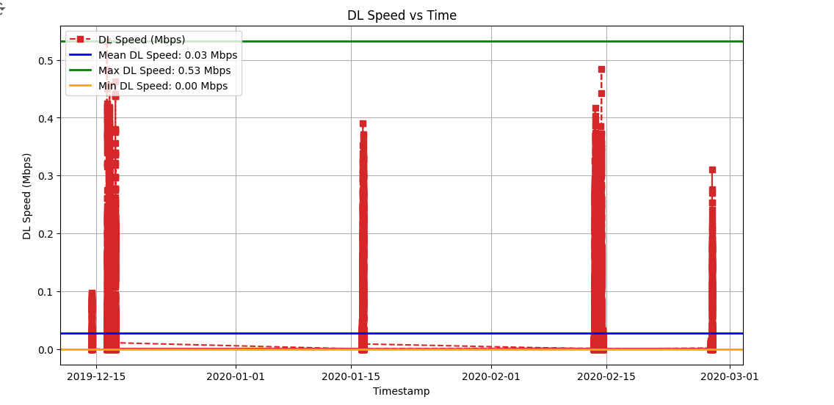

In our prediction, we will consider the Mean value of the data Download requirement as 0.03Mbps. This also tallies with similar research conducted before for the same application of autonomous driving network requirements.

Use case: We will consider an occasion with 150 cars aligned to a single gNB. The total traffic creation over that,

* Total traffic creation = 150 cars × 0.03 Mbps

= 4.5 Mbps

**Can 5G provide this requirement?** Based on the data requirement of 433.5 Mbps for 150 cars connected to a single gNB, 5G technology is well-equipped to provide the necessary bandwidth, capacity, and low latency performance needed for such scenarios.

### For the live data upstream

As per the Autonomous driving use cases, there will be uploading of images or even video live streaming, To simulate this scenario, we are using a mobile device with live streaming from a moving car.

Here we considered two live streaming for a better understanding,

* Live streaming 1 : Animated movie in Amazon Prime
* Live Streaming 2 : Movie from Netflix

|  |  |
| --- | --- |
|  |  |

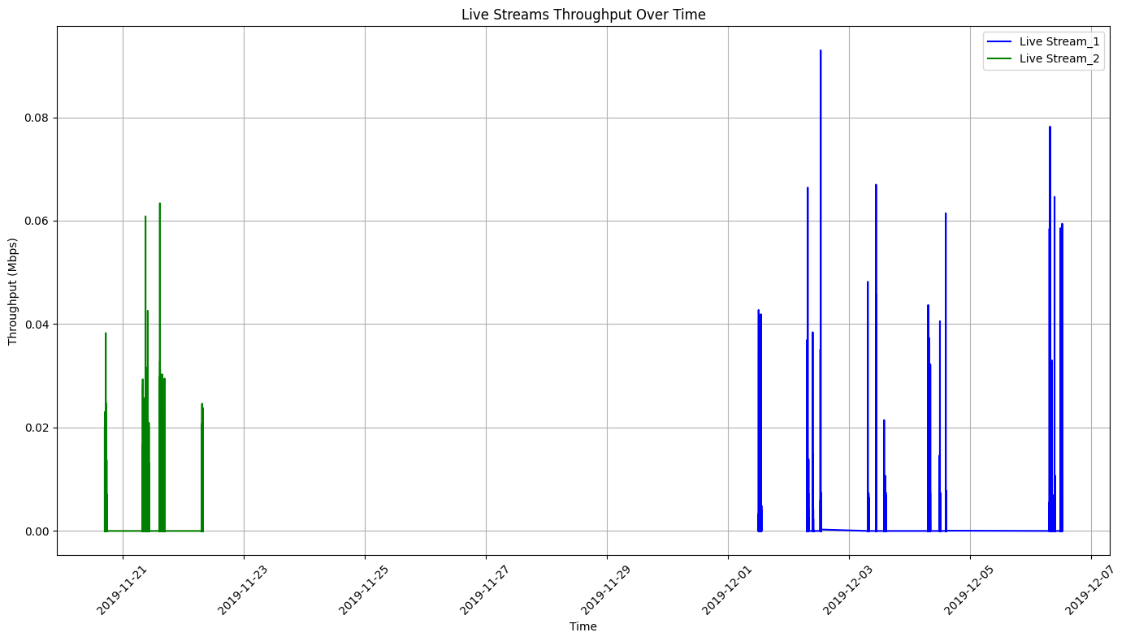

For our scenario, we will consider the Stream 1+ Stream 1 data. Still, this will sum up the multiple video streams and sensor details that are being uploaded for remote processing requirements in autonomous driving.

As the mean value of 0.00693+0.002926 will be equivalent to the upload requirement of the Fully Autonomous Driving applications.

Use case: We will consider an occasion with 150 cars aligned to a single gNB. The total traffic creation over that,

* Total bandwidth = 150 cars × (0.00693+0.002926) Mbps

= 1.4784 Mbps

**Can 5G provide this requirement?** 5G networks are well-equipped to provide the necessary bandwidth (0.009856 Mbps in this case) to support simultaneous data demands from 150 cars, each requiring 1.4784 Mbps. The deployment strategy, spectrum allocation, and network configuration will influence how efficiently 5G can deliver the required bandwidth in real-world scenarios.

## V2N Traffic Expectations: Factors Affecting the Throughput

Note: All the following graphs and predictions are based on the open data set in, GitHub - uccmisl/5Gdataset: In this work, they present a 5G trace dataset collected from a major Irish mobile operator. The dataset is generated from two mobility patterns (static and car) and across two application patterns (video streaming and file download). Case 1: Dynamic users and Static users preferences

**Case 1:** Non like in static users we have to consider that the cars will be getting good coverage (RSRP levels) at certain points and bad coverage when it is away from the base station or in terrain issues(buildings, mountains, tunnels)

**The traffic Distribution for Dynamic users is so diverse that they will not receive good RSRP levels at all times as expected**.

Probability Density Function (PDF) and Density: the relative likelihood of a random variable (in this case, RSRP values) taking on specific values. These density values are not percentages but rather values that, when integrated over the entire variable range, sum up to 1 (representing the total probability).

Dynamic User RSRP values recorded

* Around 12% of the total journey will be receiving poor RSRP levels

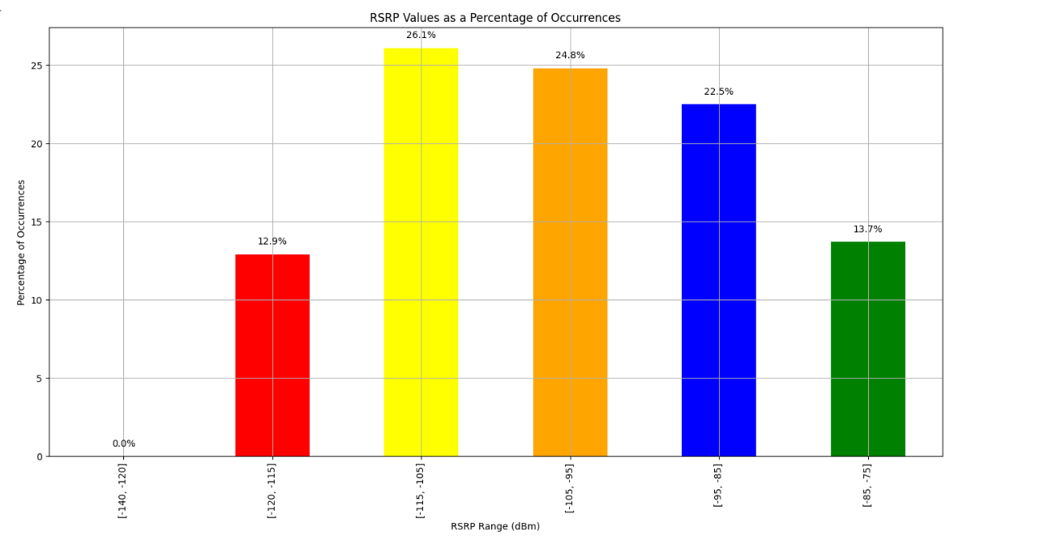

**Case 2:** The SNR is the Signal to Noice (SINR) in telecommunication. The bigger the interferences lower the download speed. So in high-traffic areas with higher station density, the network SINR will be poor and the DL speed will be again slower than expected. Also when the user count is higher or with terrain issues the SINR is poor and so is the DL and UL throughput.

**Case 3:** The vehicle speed will directly impact the DL and UL throughput values.

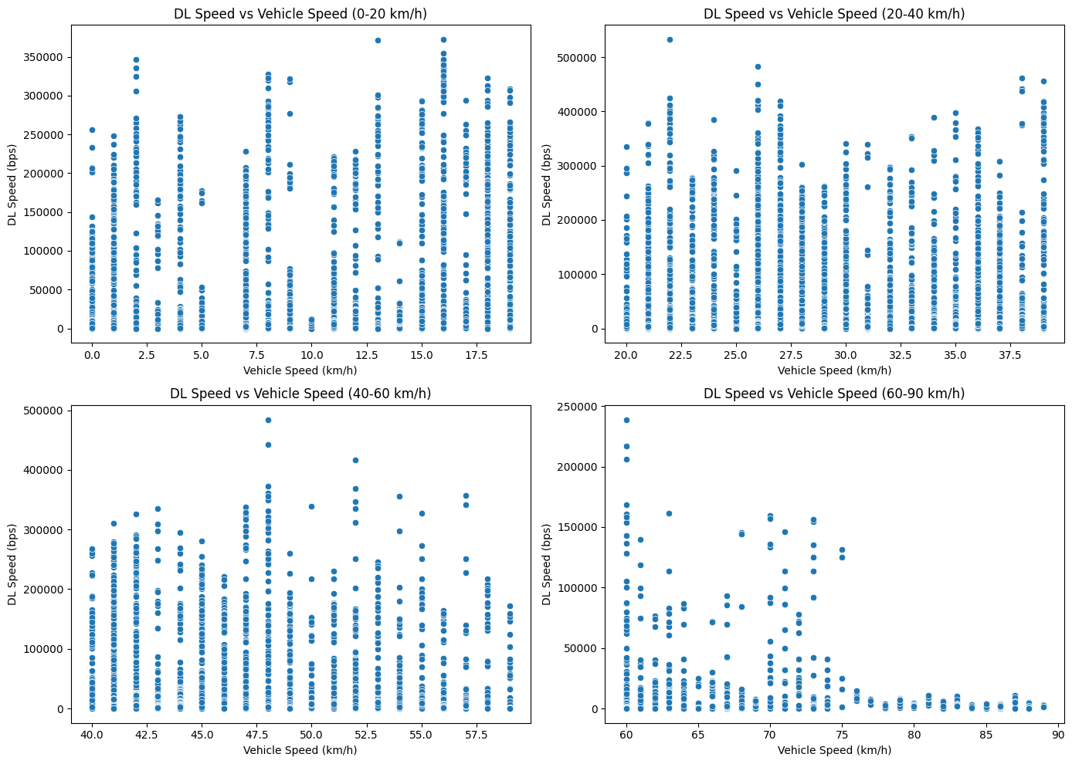

I have used ML linear regression for the same data set to predict the DL speed based on the vehicle speed.

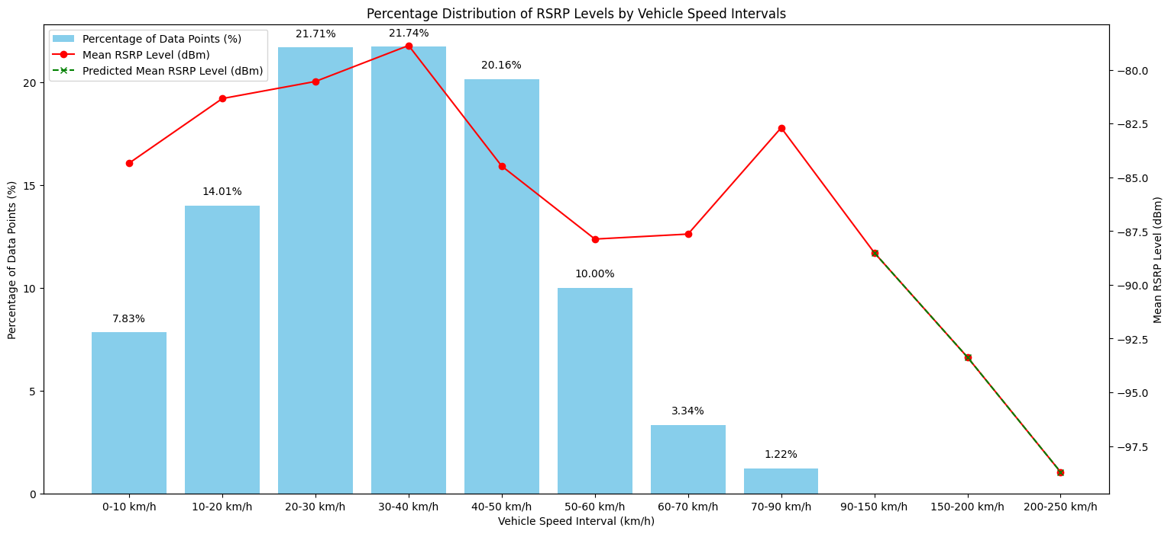

|  |  |
| --- | --- |
| Speed Interval | Average RSRP level Recorded |
| 0-10 km/h | -84.335493 |
| 10-20 km/h | -81.332730 |
| 20-30 km/h | -80.536150 |
| 30-40 km/h | -78.863811 |
| 40-50 km/h | -84.474555 |
| 50-60 km/h | -87.869518 |
| 60-70 km/h | -87.637351 |
| 70-90 km/h | -82.690476 |
| 90-150 km/h | -88.504438 |
| 150-200 km/h | -93.366099 |
| 200-250 km/h | -98.710506 |

We can’t use linear regression to the data set as it is

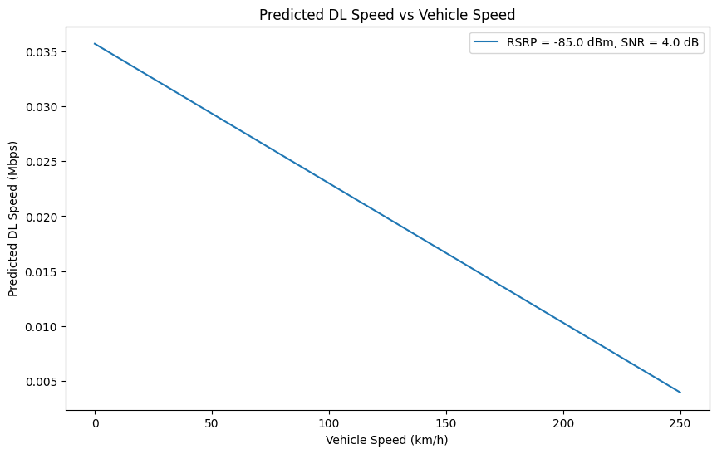

Based on the previous research on [(PDF) Handover Management in Dense Cellular Networks: A Stochastic Geometry Approach (researchgate.net)](https://www.researchgate.net/publication/301818098_Handover_Management_in_Dense_Cellular_Networks_A_Stochastic_Geometry_Approach), I could say our predictions are accurate,

[(PDF) Handover Management in Dense Cellular Networks: A Stochastic Geometry Approach (researchgate.net)](https://www.researchgate.net/publication/301818098_Handover_Management_in_Dense_Cellular_Networks_A_Stochastic_Geometry_Approach)

**Suggestion:** In expressways with relatively higher speed limits (>140kmph) or no speed limits are applied, autonomous driving may require, antennas turned towards the highways to maintain better RSRP and SINR levels or even line of sight so the DL and UL requirements can be fulfilled within the required limit.

|  |  |  |  |  |  |  |
| --- | --- | --- | --- | --- | --- | --- |
| **Data Requirements/Thresholds** | **Link** | **Direction** | **Predicted Data Rate per car** | **Standard from 3Gpp** | **Can 5G Provide this** | **Comments** |
| Signalling and basic sensor data generated (300-byte packer size) | V2N | Downlink | 0.4 Mbps | SL: 10-50 Mbps | Yes | However, the latency requirements are not met |
| Download (Traffic/weather,…) | V2N | Downlink | 0.03 Mbps-Need to revisit on this | 50 Mbps | Yes |  |
| Uplink (Live stream, data for Edge server,….) | V2N | Uplink | 0.009856 Mbps  Need to revisit on this | 0.25-10 Mbps | Yes, but higher Utilization | Will sum up to a higher Uplink traffic |
| Infrastructure (300-byte packer size) | I2V | Broadcasting | 0.01 Mbps | SL: 10-50 Mbps | Yes | Will be a side link traffic, Connected to GNb directly |
| HARQ generated + Data | V2V | Unicast | 2.92 Mbps | SL: 10-50 Mbps | Need to re-consider | generate high data rates at high speeds and will require powerful antennas |

**Summary Data Volumes**

**Coverage Summary**

|  |  |  |  |  |  |
| --- | --- | --- | --- | --- | --- |
| **Requirements/Thresholds** | **Link** | **Direction** | **Thresholds** | **Can 5G Provide this** | **Comments** |
| Signalling and basic sensor data generated | V2N | Downlink/ Uplink | Latency <30ms | No | The current network latency is 44ms |
| Coverage- Receiving power | V2N | Downlink/ Uplink | RSRP (>-116) | NO | The current network infrastructure focuses on static users |
| Interferences | V2X/ V2N | Downlink/ Uplink | SINR>3 | Need to re-consider | There will be many more interferences in the future |
| Base Stations | V2N | Downlink/ Uplink | RSRP (>-116) | NO | Need more base Stations to cover car parks, tunnels and in build solutions to underground parking |
| Coverage- RSRP Thresholds | V2N | Downlink/ Uplink | Handover when RSRP (>-116) | NO | It will not handover until  (-120 dbm) |
| Coverage at Expressways | V2N | Downlink/ Uplink | DL<0.03 Mbps UL<0.0099Mbps | NO | High speeds like 250Kmph will reduce the Throughput by around 6 times the average |

**Utilization Summary – Will include the utilization for 150 cars and what will be the total number of vehicles a 5G GnB can have in a specific use case-In Progress**

Based on the above, calculations and limitations we will predict how many Autonomous vehicles a single GNb and accommodate.

* Downlink Capacity: 20 Gbps (20,000 Mbps)
* Uplink Capacity: 10 Gbps (10,000 Mbps)

We need to add the HARQ data to both the downlink and uplink traffic calculations.

**Downlink (DL) Traffic:**

Signalling and basic sensor data: 0.4 Mbps

Download (Traffic/weather, etc.): 0.03 Mbps (need to revisit)

HARQ+ Data (added to both DL and UL): 2.92 Mbps

Total Downlink Traffic per Car=0.4 Mbps+0.03 Mbps+2.92 Mbps=6.21 Mbps

**Uplink (UL) Traffic:**

Uplink (Live stream, data for Edge server, etc.): 5.73 Mbps

HARQ+ Data (added to both DL and UL): 2.92 Mbps

Total Uplink Traffic per Car=5.73 Mbps+2.92 Mbps=8.65 Mbps

**Number of Cars Calculation:**

Downlink Capacity:

Number of Cars (DL)= Total Downlink Traffic per Car/Total Downlink Capacity

​Number of Cars (DL)= 20,000 Mbps/6.21 Mbps

​

Uplink Capacity:

Number of Cars (UL)=Total Uplink Capacity/Total Uplink Traffic per Car

Number of Cars (UL)= 10,000 Mbps/6.21 Mbps

But again, we need to consider the traffic generated by pedestrians and static users. The traffic predictions are required to be considered to make accurate assumptions

## Define the RSRP Threshold value

By sampling the records into 1-second time frames, the DL bit rate was recorded below for the entire DT.

To determine the minimum RSRP level, we will consider the least recorded RSRP values for each vehicle speed where the data bit rate has reached the minimum level,

* Here we have identified the -116 as the minimum level at an average vehicle speed of 44.29 Kmph.

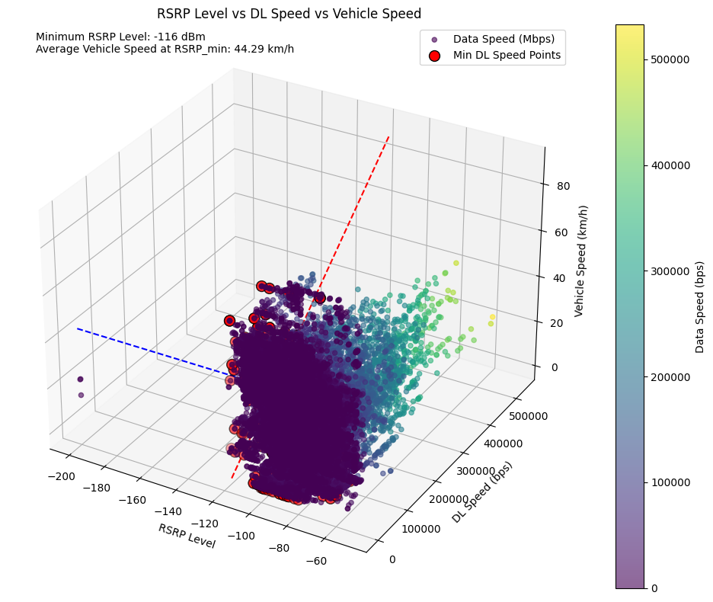

To support our calculation, we can see in the Drive test that when the RSRP value reached a -116 level it fell back to another network mode 4G or 3G. When a dedicated download is conducted and based on the hierarchy a mobile subscriber will automatically latch to the higher order Network. In this case, it is 5G and when the 5G network cannot provide the needed resources (when the RSRP level is reduced) it will automatically fall back to LTE or even to 3G.

|  |  |  |  |  |  |
| --- | --- | --- | --- | --- | --- |
| **Network Mode** | **Record Count** | **Average of DL_bitrate** | **Max of RSRP** | **Min of RSRP** | **Average of RSRP** |
| 5G | 13959 | 46175,26 | -50 | -116 | -82,8 |
| HSDPA | 41 | 1145,68 | -71 | -91 | -87,5 |
| HSPA+ | 4338 | 3352,02 | -51 | -101 | -70,5 |
| HSUPA | 41 | 20,85 | -57 | -95 | -85,5 |
| LTE | 9204 | 11113,40 | -49 | -200 | -87,3 |
| UMTS | 8 | 0,00 | -77 | -95 | -83,5 |
| **Grand Total** | **27591** | **27597,30013** | **-49** | **-200** | **-82,37** |

Therefore, in the current mobile infrastructure the NR V2X. V2N network RSRP threshold will be -116 based on these DT results.

We will continue to predict the RSRP threshold for a high speeding scenario when the vehicle moves at 250kmph, as shown below. We have used a linear regression ML model to determine it,

With the increase in speed, the RSRP requirement has also increased. Therefore, on the expressway, a better RSRP value of higher than -99.49 dBm may be required.

### V2X RSRP thresholds

Edge server RSRP Threshold: In progress

Only A can use the Edge server facilities.

Up to here it's all ok

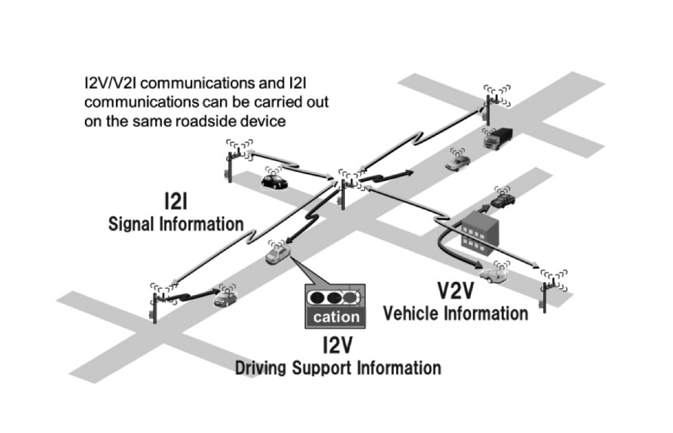

Table 2. Application examples of V2V, I2V/V2I, and I2I communications systems

Here we focus more on the v2n and some aspects of I2V, and V2I and we will not be considering I2I as at this stage It will not be implemented related to this project. However, following are some applications of I2I.

Table 3. Applications using I2I communications.

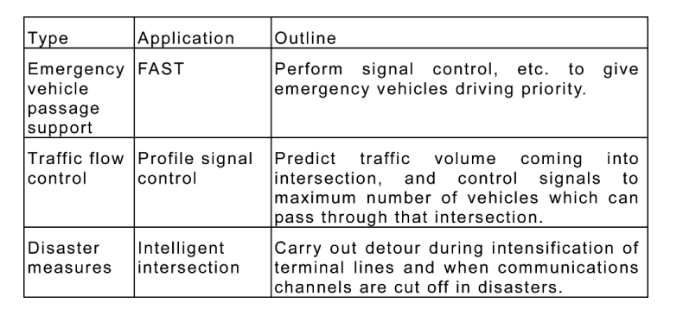

The radio communication requirements based on the vehicle speed**:**

* To be comprised of base stations and mobile stations, and radio communications among them to operate with a single channel in the 700 MHz band, and accommodate both Roadside-to-Vehicle and Inter-Vehicle Communications
* To support Inter-Vehicle Communications at a relative speed of up to **140 km/h**

(In Finland we have a maximum of 100 km/h ) [Information about changes to speed limits | Traficom](https://www.traficom.fi/en/transport/road/information-about-changes-speed-limits)

* To support Roadside-to-Vehicle Communications at a vehicle speed of up to **70 km/h**,

(In highways/expressways near the junctions and colour lights the speed limit is slightly lower ~ 60 km/h, and the speed limit is slightly lower, around 60 km/h, on highways/expressways near junctions and traffic lights. However, vehicles travelling faster than 70 km/h in traffic and busy areas will have limitations in receiving the most accurate real-time guidance.

# References

[Stopping Distance Calculator (omnicalculator.com)](https://www.omnicalculator.com/physics/stopping-distance)

[Stopping Distance Calculator (omnicalculator.com)](https://www.omnicalculator.com/physics/stopping-distance)

[You Can't Beat Physics! - South Brisbane (mypolice.qld.gov.au)](https://mypolice.qld.gov.au/southbrisbane/2013/01/14/you-cant-beat-physics/)

[Stopping Distance 101: Reaction, Braking Distance & Formula (zutobi.com)](https://zutobi.com/us/driver-guides/reaction-braking-stopping-distance)

[(PDF) Analysis of Data Collected by the 700 MHz Band Intelligent Transport Systems for Reducing Ambulance Transportation Time (researchgate.net)](https://www.researchgate.net/publication/338800245_Analysis_of_Data_Collected_by_the_700_MHz_Band_Intelligent_Transport_Systems_for_Reducing_Ambulance_Transportation_Time#fullTextFileContent)

[System Level Analysis for ITS-G5 and LTE-V2X Performance Comparison (hal.science)](https://cea.hal.science/cea-02519732/file/System_Level_Analysis_for_ITS_G5_and_LTE_V2X_Performance_Comparison.pdf)

A Comparison of the V2X Communication Systems_ ITS-G5 and C-V2X.pdf

[2002.11450 (arxiv.org)](https://arxiv.org/pdf/2002.11450)

[2002.11450 (arxiv.org)](https://arxiv.org/pdf/2002.11450)

[ITS Stack (qualcomm.com)](https://www.qualcomm.com/content/dam/qcomm-martech/dm-assets/documents/c-v2x_its_stack.pdf)

[(arxiv.org)](https://arxiv.org/pdf/2102.04538)

[2311.16810 (arxiv.org)](https://arxiv.org/pdf/2311.16810)